Project Title – To Supply the Leftover Food to Poor

# Project Overview

This project is focused on creating a sustainable system to redistribute leftover food to people in need. The primary challenge we are addressing is food waste and hunger in local communities. The goal is to implement a solution that efficiently collects, stores, and distributes surplus food from restaurants, events, and households to impoverished individuals and families. By leveraging a mobile app platform and local partnerships, this project aims to reduce food waste, improve food security, and support the long-term goal of reducing hunger in underprivileged areas.

# Objectives

**Business Goals:**

1. **Reduce Food Waste:** Minimize the amount of edible food discarded by redirecting it to those in need, creating a more sustainable food system.
2. **Support Vulnerable Communities:** Provide regular access to nutritious meals for individuals and families living in poverty or experiencing food insecurity.
3. **Build Community Partnerships:** Foster collaborations with local restaurants, grocery stores, and organizations to create a network of reliable food donors and volunteers.
4. **Enhance Social Responsibility:** Encourage businesses and individuals to engage in social responsibility by contributing to the well-being of their communities.

**Specific Outcomes:**

1. **Efficient Collection & Distribution System:** Develop and implement a system that enables the timely collection of surplus food and its redistribution within a set time frame, ensuring food safety and quality.
2. **Mobile App for Coordination:** Launch a mobile app that connects donors, volunteers, and recipients, streamlining communication, pick-up requests, and tracking.
3. **Data Analytics on Food Donation Patterns:** Track and analyse food donation patterns to optimize the supply chain and identify areas with high food surplus and demand.
4. **Monthly Outreach Events:** Organize at least one community outreach event per month to raise awareness, attract new donors, and encourage community involvement.

# Sales force Key Features and Concepts Utilized

**1. Non-profit Cloud:**

* **Donor and Volunteer Management:** Use Non-profit Cloud to manage and track relationships with food donors (restaurants, stores) and volunteers. Allows for efficient tracking of donation history, volunteer hours, and impact metrics.
* **Household and Individual Accounts:** Organize beneficiaries into households or individual accounts to better track food distribution and needs over time.

**2. Sales force Mobile App:**

* **Real-Time Notifications and Scheduling:** Enable real-time notifications for donation pickups and volunteer coordination. Volunteers can confirm availability and see tasks on the go, facilitating timely food collection and delivery.

**3. Service Cloud:**

* **Case Management:** Each donation or request is treated as a case, allowing for easy tracking from collection to delivery. Cases can be assigned to volunteers, prioritized based on food type and urgency, and tracked for resolution.
* **Knowledge Base:** Build a knowledge base with guides on food handling, donation procedures, and community guidelines, accessible to volunteers and donors for best practices.

**4. Sales force Reports and Dashboards:**

* **Impact Tracking:** Create custom dashboards to visualize the volume of food collected, the number of people served, and other KPIs such as reduction in food waste and community impact.
* **Donation and Volunteer Trends:** Reports on donation patterns, volunteer engagement, and demand areas to optimize resources and focus on high-impact areas.

**5. Marketing Cloud for Community Engagement:**

* **Email and SMS Campaigns:** Engage donors, recipients, and volunteers with personalized email and SMS updates on donation needs, impact stories, and upcoming events.
* **Social Media Integration:** Spread awareness of the program, attract new donors, and share success stories through integrated social media campaigns.

**6. Automation with Flow:**

* **Automated Workflows:** Use Sales force Flow to automate routine tasks, such as confirming donation pickups, notifying volunteers of new opportunities, and assigning cases.
* **Approval Processes:** Implement approval processes for volunteer applications, donation requests, and high-priority cases, ensuring all actions are properly reviewed and approved.

# Detailed Steps to Solution Design

**Solution Overview:** The project involves designing a Sales force solution for food collection and redistribution, using Non-profit Cloud, Service Cloud, and custom workflows to manage donors, recipients, volunteers, and donation logistics. Key components include data models for different user types, custom screens for ease of use, and business logic to automate routine tasks and optimize workflows.

**Step 1: Data Model Design**

1. **Objects and Relationships:**
   * **Donor (Account):** Stores details of each food donor (e.g., restaurants, grocery stores) with fields for contact information, donation frequency, and food type preferences.
   * **Volunteer (Contact):** Details of volunteers who assist with food pickups and deliveries, including skills, availability, and completed hours.
   * **Recipient (Account/Contact):** Information on individuals or households receiving food assistance, including dietary needs, household size, and distribution preferences.
   * **Donation (Custom Object):** Tracks each food donation, with fields for item description, quantity, pickup and expiry dates, status, and assigned volunteer.
   * **Delivery (Custom Object):** Tracks each delivery case, linking donations with recipients and volunteers, with fields for delivery status, time, and location.
   * **Event (Custom Object):** Tracks community outreach events, with fields for event date, location, sponsors, and participant numbers.
2. **Relationships:** 
   * **One-to-Many:** Each donor can have multiple donations; each recipient can receive multiple deliveries.
   * **Many-to-Many (Junction Object):** A junction object connects volunteers to specific donations they handle, allowing flexible assignment.

**Step 2: User Interface (UI) Design**

1. **Custom Screens and Page Layouts:**
   * **Donor Profile Page:** Displays donor information, donation history, and contact information. Includes an embedded “New Donation” button for quick entries.
   * **Volunteer Dashboard:** A personalized dashboard showing a volunteer’s scheduled pickups, deliveries, and total hours.
   * **Donation Management Screen:** Allows users to view, edit, and update donation details. Contains tabs for “Upcoming Pickups,” “Urgent Donations,” and “Recent Deliveries.”
   * **Recipient Profile Page:** Summarizes recipient needs, recent deliveries, and special dietary requirements.
2. **Mobile App Interface:**
   * **Real-Time Notifications and Maps:** Interface includes notifications for new tasks, donation pickups, and GPS-enabled map views to optimize volunteer routes.
   * **Quick Action Buttons:** "Accept Pickup," "Mark as Delivered," and "Report Issue" buttons for streamlined volunteer actions on mobile.
3. **Screenshots:** Each page layout should have accompanying screenshots showing field placements, buttons, and tab organization.

**Step 3: Business Logic**

1. **Automation with Sales force Flow:**
   * **Donation Creation Workflow:** Triggers when a new donation is created, automatically assigning the donation to the nearest available volunteer based on location and availability.
   * **Case Status Updates:** Automated status updates for donations and deliveries (e.g., "Pending Pickup," "In Transit," "Delivered").
   * **Notification Workflow:** Volunteers receive notifications via the Sales force mobile app when a new pickup or delivery is assigned to them.
2. **Approval Processes:**
   * **Volunteer Application Approval:** Automated process for reviewing and approving new volunteer applications.
   * **Donation Quality Check:** Workflow requiring manager approval for donations marked as urgent or high-priority, ensuring proper handling.
3. **Validation Rules:**
   * **Food Expiry Check:** Ensures that donated food has a minimum of 24 hours before expiry at the time of pickup.
   * **Volunteer Capacity Check:** Prevents over-assignment of tasks to volunteers by validating their availability.

**Step 4: Reports and Dashboards**

1. **Impact Dashboard:**
   * **Food Distributed by Category:** A visual report showing quantities of different types of food distributed.
   * **Monthly Volunteer Engagement:** Tracks volunteer participation levels by hours and number of deliveries completed.
2. **Donation Trends Report:**
   * **Peak Donation Times:** Identifies days and times with high donation activity, helping optimize scheduling.
   * **Donor Retention Rates:** Tracks how often donors contribute, aiding in targeted retention efforts.
3. **Screenshot Samples:** Include images of dashboard designs, illustrating key performance indicators (KPIs) and graphical data visualizations.

# Testing and Validation

**Testing is critical to ensure that the Sales force solution functions as intended.** The approach focuses on comprehensive testing at each layer, including back-end logic, workflows, and front-end usability. Testing involves unit tests, user interface tests, and validation against defined requirements to ensure seamless functionality and user satisfaction.

**Unit Testing (Apex Classes, Triggers)**

1. **Apex Class Testing:**
   * **Objective:** Validate that each Apex class performs as expected, especially those involving complex business logic, workflows, and data processing.
   * **Process:** Develop test classes that cover all methods in each Apex class. Use test data to simulate real scenarios for donors, volunteers, recipients, and donations.
   * **Coverage Goal:** Aim for a minimum of 75% code coverage across all Apex classes, which is the Salesforce recommended minimum. This includes testing both typical use cases and edge cases, such as handling of incomplete data or unexpected input formats.
2. **Trigger Testing:**
   * **Objective:** Test triggers that handle critical automation tasks, such as assignment of volunteers to donations, automated notifications, and status updates.
   * **Process:** Create unit tests for each trigger, simulating actions that would fire the trigger (e.g., new donation creation, delivery completion).
   * **Coverage Goal:** Ensure that triggers execute properly and achieve full code coverage, testing all conditional branches within each trigger to validate each workflow.
3. **Error Handling and Exception Testing:**
   * **Objective:** Ensure that error messages and exceptions are handled gracefully without system disruption.
   * **Process:** Simulate scenarios that might lead to errors (e.g., missing data, data type mismatches) and check that appropriate error messages are displayed and logged.

**User Interface (UI) Testing**

1. **User Interface Functionality Testing:**
   * **Objective:** Ensure that all Salesforce custom screens, page layouts, and mobile interfaces function as expected and meet design specifications.
   * **Process:** Create test cases for each user type (e.g., donor, volunteer, administrator) to cover key interface interactions, such as creating donations, viewing dashboards, updating records, and using quick action buttons.
   * **Validation Criteria:** Ensure fields display accurate data, button actions (e.g., "Accept Pickup," "Mark as Delivered") work correctly, and page navigation is smooth.
2. **Mobile UI Testing:**
   * **Objective:** Validate that the Salesforce mobile app displays user interfaces accurately and that volunteers can navigate tasks, notifications, and maps effectively on mobile devices.
   * **Process:** Conduct tests on multiple mobile devices (e.g., iOS, Android) to ensure compatibility and usability. Test mobile-specific features, like real-time notifications, quick action buttons, and GPS functionality for route optimization.
   * **Validation Criteria:** Confirm that layout and functionality remain intact across devices, and actions like "Report Issue" or "Mark as Delivered" work as intended.
3. **Cross-Browser Testing:**
   * **Objective:** Ensure that the user interface is consistent and responsive across all commonly used web browsers.
   * **Process:** Test the solution on multiple browsers (e.g., Chrome, Firefox, Safari, Edge) to ensure functionality and UI consistency.
   * **Validation Criteria:** Ensure no visual or functional discrepancies across browsers, with special attention to responsive elements, font rendering, and button layouts.

**End-to-End Testing and Validation**

1. **End-to-End Workflow Testing:**
   * **Objective:** Simulate full donation cycles to ensure that workflows (from donation entry to recipient delivery) function seamlessly.
   * **Process:** Create test scenarios that cover complete processes, including donation creation, volunteer assignment, delivery scheduling, and feedback loops.
   * **Validation Criteria:** Validate that each step in the workflow is accurately executed, with updates in real-time and all data flowing through correctly.
2. **User Acceptance Testing (UAT):**
   * **Objective:** Engage a small group of end-users (e.g., volunteers, donors, and admins) to test the system in a real-world environment.
   * **Process:** Allow users to perform typical tasks within the system and report any issues or feedback.
   * **Validation Criteria:** Gather and incorporate feedback to enhance the user experience and address any potential challenges before full launch.
3. **Performance Testing:**
   * **Objective:** Confirm that the system can handle peak usage times without degradation in performance.
   * **Process:** Simulate high-traffic scenarios (e.g., high donation volume, multiple user logins) to test system speed, loading times, and response.
   * **Validation Criteria:** Ensure the system remains responsive and functions well under load, with minimal lag in data entry, reporting, and notification delivery.

This testing and validation approach helps ensure a reliable, high-quality Salesforce solution that meets functional, performance, and user satisfaction standards. By covering unit testing, UI testing, and full workflow validations, the solution will be fully ready for deployment with minimal risk of issues post-launch.

# Key Scenarios Addressed by Salesforce in the Implementation Project

This gives clarity that you are addressing various use cases or situations that Salesforce can handle during the implementation.

In this project, Salesforce is used to address several critical scenarios that facilitate the effective collection and redistribution of leftover food. The solution ensures that all parties, from donors to recipients, experience a seamless, efficient, and reliable process.

**Scenario 1: Donor Food Contribution and Management**

**Use Case:** Restaurants, grocery stores, and other food providers want to donate surplus food, with minimal administrative burden and clear communication.

**Solution:** Salesforce’s Nonprofit Cloud provides a streamlined way for donors to log donations with essential details such as food type, quantity, pickup date, and expiry date. The Donor Profile page allows easy viewing of donation history and preference management, while the "New Donation" button facilitates quick entries. Notifications update donors on the status of their donations, ensuring transparency and engagement.

**Scenario 2: Automated Volunteer Assignment for Donation Pickups**

**Use Case:** Volunteers need to be matched with donation pickups based on location, availability, and current task load to ensure efficiency.

**Solution:** Using Salesforce Flow and custom business logic, the system automatically assigns available volunteers to new donations based on predefined criteria such as location proximity, availability, and task capacity. Volunteers receive instant notifications through the Salesforce mobile app when a pickup is assigned, allowing them to confirm availability and access directions via GPS.

**Scenario 3: Efficient Donation Pickup and Delivery Tracking**

**Use Case:** Coordinators need real-time insights into the status of each donation from pickup through to delivery, ensuring that food reaches recipients in a timely manner.

**Solution:** Service Cloud’s case management system and custom Donation and Delivery objects allow coordinators to track each donation in real time. Case status updates (e.g., “Pending Pickup,” “In Transit,” “Delivered”) provide transparency at every stage, helping coordinators monitor progress and reassign tasks as needed. The Volunteer Dashboard provides visibility into ongoing tasks, enabling volunteers to update statuses directly from the mobile app.

**Scenario 4: Recipient Needs Tracking and Distribution Scheduling**

**Use Case:** Organizations need to manage and record food distributions to recipients, including household needs and preferences, to ensure fair and equitable distribution.

**Solution:** Salesforce stores recipient information in the Recipient Profile, including dietary requirements, household size, and food preferences. Coordinators can view recipient history and tailor distributions based on specific needs. Distribution scheduling is streamlined by linking donations to recipients, ensuring that food is distributed promptly and according to preferences.

**Scenario 5: Real-Time Notifications and Communication**

**Use Case:** Volunteers, donors, and coordinators need timely updates and reminders to coordinate donations, pickups, and deliveries effectively.

**Solution:** Salesforce’s notification workflows send real-time alerts for new pickups, delivery assignments, and urgent donations that require immediate attention. Volunteers receive reminders before scheduled pickups and can confirm task completion directly from the mobile app. Donors are also notified once their contributions are picked up, providing them with confirmation and closing the feedback loop.

**Scenario 6: Impact Tracking and Reporting for Stakeholders**

**Use Case:** The organization needs to monitor and report on food redistribution impact, volunteer engagement, and donor participation to demonstrate the project’s effectiveness.

**Solution:** Salesforce Reports and Dashboards provide a visual representation of the program’s impact. Dashboards track metrics like food distributed by category, volunteer engagement hours, donor retention, and peak donation times. These reports help stakeholders understand the program’s impact on food waste reduction and community support, making it easy to communicate results to sponsors, partners, and the public.

**Scenario 7: Volunteer Application and Approval Process**

**Use Case:** New volunteers need an easy way to apply and become approved for participation, with minimal administrative overhead.

**Solution:** Salesforce’s automated approval process manages new volunteer applications, streamlining the onboarding process. Prospective volunteers submit their applications through the platform, and the system routes these applications for manager review and approval. This automation allows coordinators to quickly expand the volunteer base without manual intervention.

**Scenario 8: Managing High-Priority and Perishable Donations**

**Use Case:** Certain food items may have shorter shelf lives or higher priority for distribution and require expedited handling.

**Solution:** Salesforce’s business rules and approval workflows prioritize high-risk or perishable donations, routing them for immediate volunteer assignment. The “Donation Quality Check” process sends these donations for manager review, ensuring swift action to prevent food spoilage. Volunteers are alerted of these high-priority tasks in real time, enabling them to expedite the pickup and delivery.

**Scenario 9: Organizing Community Outreach Events**

**Use Case:** The organization wants to host community events to promote food security awareness, increase donations, and engage volunteers.

**Solution:** Salesforce’s Event object tracks community events, including scheduling, location, sponsorship, and participant numbers. This feature allows coordinators to organize and manage events, track volunteer and donor participation, and gather insights for future event planning. Reports on event outcomes can be shared with stakeholders to highlight the organization’s community involvement and outreach efforts.

**Summary**

Each scenario addressed by Salesforce helps to create an efficient, reliable, and scalable solution for managing food donations, volunteer coordination, and food distribution. The system’s ability to automate routine processes, track detailed data, and provide real-time notifications ensures that the project is well-equipped to meet its mission of reducing food waste and supporting those in need.

**7. Output**

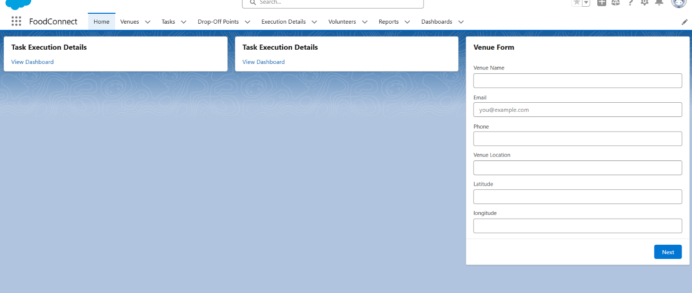

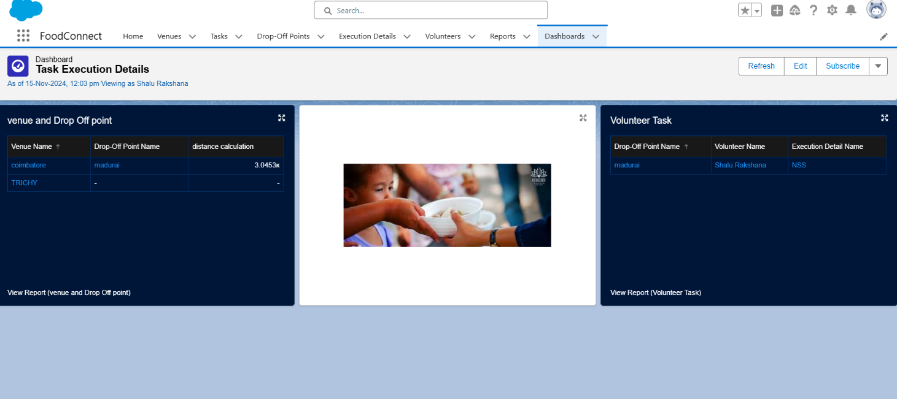

# 8.Conclusion

The Salesforce implementation has created a seamless, scalable solution for managing food donations and distribution, connecting donors, volunteers, and recipients to reduce food waste and support those in need. Key achievements include:

* **Efficient Donation & Volunteer Management:** Streamlined donor contributions and automated volunteer assignments based on location and availability.
* **Real-Time Tracking & Notifications:** Enabled real-time tracking and updates, ensuring transparency in the donation process.
* **Impact Reporting:** Developed dashboards and reports to track distribution, volunteer engagement, and donor retention.
* **Enhanced Community Engagement:** Supported volunteer onboarding and organized community events to increase participation.

This project effectively meets its goals of reducing food waste and alleviating hunger, serving as a replicable model for similar initiatives.